Preparation for Mid term Exam
asst. Granit Nebiu
Course: Data Structure

How data is organized?
  - Place data contiguously
  - Place data here and there with “links”
  - Place data with “formula”

Basic data types a language supports?
Integer, float, double, char, boolean
string: usually an array of char supported with library

What is Array? – supported by a language but needs care of array size, overflow.
What is Vector – a structure to allow handling of its size and overflow “automatically”.
Define the Linked List?- allow data connected by “links” to save space which may be wasted in an array/vector.

Examples of storage containers

What is ADT?
In computer science, an abstract data type (ADT) is a mathematical model for a certain class of data structures that have similar behavior;
What are typwa of cointainers?
1.Vector, List, Deque
2.Map (Binary Search Tree)
3.Hash map
4.Stack and Queue

Write the code for Algorithm min and max?
int min = max = at(0).getValue;
for (int i=1; i<siz(); i++) {
if ( at(i).getValue > max )
max = getValue;
if ( at(i).getValue < min )
min = getValue;
} // max and min is the result

Algorithm Analyses
To understand how good or how bad an algorithm is
Theoretically evaluate an algorithm
Execution time
Storage efficiency
Experimentally evaluate an algorithm
Use system clock to measure the execution time

Methods :
Selection sort
Insertion sort
Merge sort
Quick sort

Condition and loops statements ?
All control statements are similar
if ( statement ) {
// ...
} else if ( statement ) {
// ... while ( statement ) {
} else { // ...
// ... }
}
for ( int i = 0; i < N; ++i ) {
// ...
do { }
// ...
} while ( statement );

3

Operators:
Operators have similar functionality for built-in datatypes:
  - Assignment =
  - Arithmetic + - * / %
+= -= *= /= %=
  - Autoincrement ++
  - Autodecrement --
  - Logical && || !
  - Relational == != < <= >= >
  - Comments /* */
// to end of line
  - Bitwise & | ^ ~
&= |= ^=
  - Bit shifting << >>
<<= >>=

What is Function?
A function is a group of statements that is given a name, and which can be called from some point of the program. The most common syntax to define a function is:
type name ( parameter1, parameter2, ...) { statements }

example:

#include <iostream>
using namespace std;
// A function with a global name
int sqr( int n ) {
return n*n;
}
int main() {
cout << "The square of 3 is " << sqr(3) << endl;
return 0;
}

Libraries?
#include <iostream>
#include "Single_list.h"

The file as the unit of compilation?
This file (example.cpp) contains two functions

#include<iostream>
using namespace std;
int sqr( int n ) { // Function declaration and definition
return n*n;
}
int main() {
cout << "The square of 3 is " << sqr(3) << endl;
return 0;

What is Namespace std?
namespaces allows us to group a set of global classes, objects and/or functions under a name.

UML Class Diagrams

UML, the Unified Modeling Language is a collection of best practices used in designing/modeling (among other things) software systems.
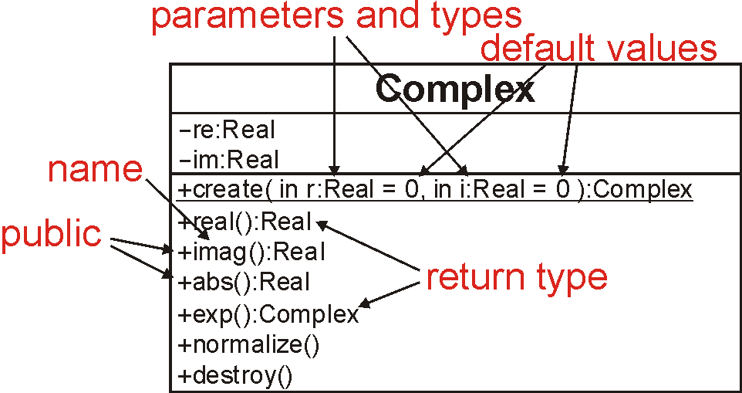
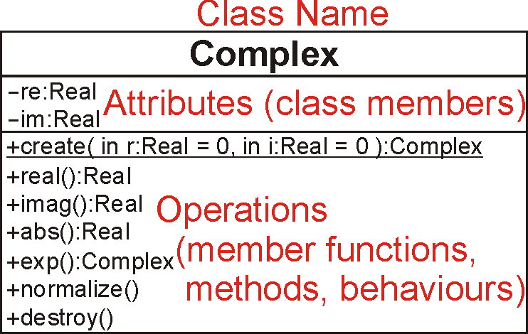

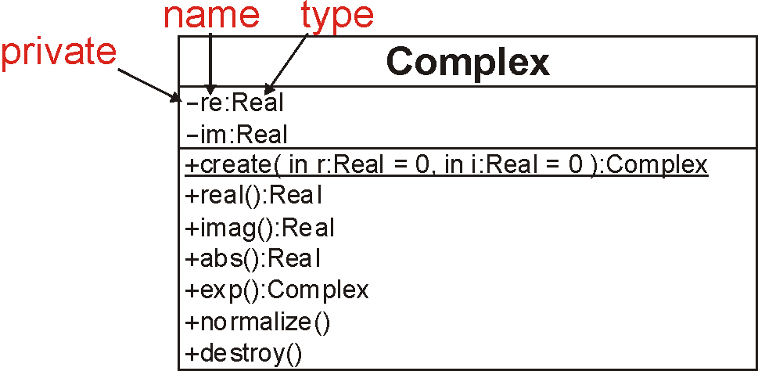

Given the UML Class diagram up contract the class code?

class Complex {
private:
double re, im;
public:
Complex( double = 0.0, double = 0.0 );
double real() const;
double imag() const;
double abs() const;
Complex exp() const;
void normalize();
};

Visibility
In C++, this is described by a block prefixed by one of
private: -
protected: #
public:+

Comment the following code?

class ClassY; // declare that ClassY is a class
class ClassX {
private:
int privy; // the variable privy is private
friend class ClassY; // ClassY is a "friend" of ClassX
};
class ClassY { // define ClassY
private:
ClassX value; // Y stores one instance of X
public:
void set_x() {
value.privy = 42; // a member function of ClassY can
} // access and modify the private
}; // member privy of "value"

Lecture2

What is Linked Lists and why we use them?
Linked lists are used to store collections of data. But we've already seen a mechanism for doing this. i.e. A collection of data can be stored in array. However, an array is a sequential structure meaning that it is a group of memory elements located in contiguous locations (located next to one another in a group).

Difference between Arrays and Link List?

Arrays
  - Simple,
  - Fast
but
  - Must specify size at construction time.
Data
Next
object
Linked list
  - Each node of the list contains
the data item (an object pointer in our ADT)
a pointer to the next node
Data
Next
object
Head
Collection
node

Collection structure has a pointer to the list head:
  - Initially NULL
Add first item
  - Allocate space for node
  - Set its data pointer to object
  - Set Next to NULL
  - Set Head to point to new node

Collection of components (nodes)
  - Every node (except last) - Contains address of the next node

Node components:
FIGURE 5-1 Structure of a node
  - Data: stores relevant information
  - Link: stores address

Two node components
  - Declared as a class or struct
Data type depends on specific application
  - Link component: pointer
Data type of pointer variable: node type itself

STRUCTUR THE TABLE ?

TABLE 5-2 Values of current, head, and some of the nodes of the linked list in Figure 5-5

Linked Lists: Some Properties

Head stores address of first node
Info stores information
Link stores address of next node

  - Assume info type int

Pointer current: same type as pointer head
  - current = head;
Copies value of head into current
  - current = current->link;
Copies value of current->link (2800) into current
FIGURE 5-5 List after the statement
current = current->link; executes

Given statements insert newNode?
Solution:
TABLE 5-3 Inserting a node in a linked list

How you can delete the node from linkList ? - Delete implementation

void *DeleteFromCollection( Collection c, void *key ) {
Node n, prev;
n = prev = c->head;
while ( n != NULL ) {
if ( KeyCmp( ItemKey( n->item ), key ) == 0 ) {
prev->next = n->next;
return n;
}
prev = n;
n = n->next;
}
return NULL;
}

How you can insert the node from linkList ? - Insert implementation
Check in slides also find the node

Linked Lists - LIFO and FIFO
What does it mean the abbreviation of LIFO AND FIFO?
    - Last-In-First-Out (LIFO) semantics
    - First-In-First-Out (FIFO)

Simplest implementation
  - Add to head
  - Last-In-First-Out (LIFO) semantics
Modifications
  - First-In-First-Out (FIFO)
  - Keep a tail pointer

What are two types of liked list?
- Two types of linked lists: sorted, unsorted.

Structure of Linked List Nodes?
Node has two instance variables
  - Simplify operations (insert, delete)
    - Define class to implement linked list node as a struct
Definition of the struct nodeType
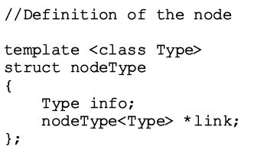

Time complexity of the operations of the class linkedList type?
TABLE 5-6 Time-complexity of the operations of the
class linkedListType

Unordered Linked Lists
  - Implement the operations search, insertFirst, insertLast, deleteNode
Search the list
  - Steps
    - Step one: Compare the search item with the current node in the list. If the info of the current node is the same as the search item, stop the search; otherwise, make the next node the current node
    - Step two: Repeat Step one until either the item is found or no more data is left in the list to compare with the search item

TABLE 5-7 Time-complexity of the operations of the
class unorderedLinkedList

What is Ordered Linked Lists?
  - Provide definitions of the abstract functions:
insertFirst, insertLast, search, deleteNode
Search the list
  - Steps describing algorithm
Step one: Compare the search item with the current node in the list. If the info of the current node is greater than or equal to the search item, stop the search; otherwise, make the next node the current node
Step two: Repeat Step one until either an item in the list that is greater than or equal to the search item is found, or no more data is left in the list to compare with the search item

Time complexity for order list ?
TABLE 5-8 Time-complexity of the operations of
the class orderedLinkedList

Doubly Linked Lists operation and how it looks like?

- Typical operations
  - Initialize the list
  - Destroy the list
FIGURE 5-27 Doubly linked list
  - Determine if list empty
  - Search list for a given item
  - Insert an item
  - Delete an item, and so on

STL Sequence Container: list
TABLE 5-9 Various ways to declare a list object

Circular Linked Lists and how they look like and basic operation?
- Last node points to the first node

What is stack?
A stack is a data structure that stores and retrieves items in a last-in-first-out (LIFO) manner
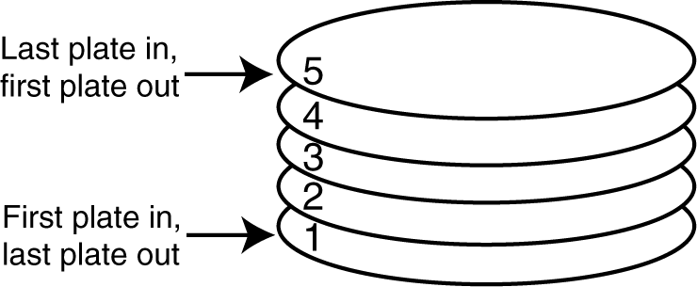

Two methods of Stack?
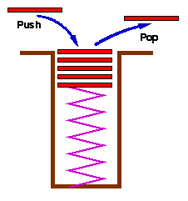
- Two methods
  - int push( Stack s, void *item );
- add item to the top of the stack
  - void *pop( Stack s );
- remove an item from the top of the stack

NOTE: There will be included also a program code that we have learnt and written during the exercises. Please share what codes you have written with your colleagues.

